Getting God’s Word into your life

Read 2 Timothy 3:14-17. What are some significant things to note about the passage?

Look up Philippians 3:10. What was Paul’s greatest desire?

If you wanted to know God, how would you do that?
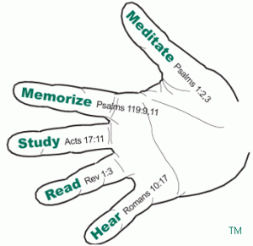

Look up the following verses. What do they say about getting God’s Word into your life?

1. Romans 10:17 ________________ God’s Word from leaders, online sermons and books.

How can we know the leaders, sermons, and books we hear are accurate and true?

2. Revelation 1:3 ________________ God’s Word with a plan during your quiet time.

How much of God’s word are you reading on a daily basis? Do you feel like this needs to change?

3. Acts 17:11 ________________ God’s Word and go deeper to discover meaning.

4. Psalm 119:11 ________________ God’s Word to get it into your heart.

5. Psalm 1:2–3 ________________ on God’s Word thinking deeply about the meaning of the verses.

What are some of the benefits of meditating on God’s word?

6. James 1:22 ________________ God’s Word making practical applications to do what you learn.

What are the dangers of understanding God’s word but not obeying?

We see throughput history and the Bible itself, the more someone immerses themselves in God’s word; the more their relationship with God grows. All of these need to become consistent habits in our life over time. In fact, it may take some trial-and-error for this to happen. Do not be discouraged! Press forward and strive to make small changes.

Which of these areas are you strongest in? Weakest? Why?

Pick one of these areas where God is leading you to focus on this week. Set a goal of how you will do that and discuss together.

